Create the Access key and secrete access key in AWS account

Configure the account using

Aws configure

Go to the user profile .aws folder and then add the another account Access key and security access key in credentials file

Open the config file and then add the region and output format value

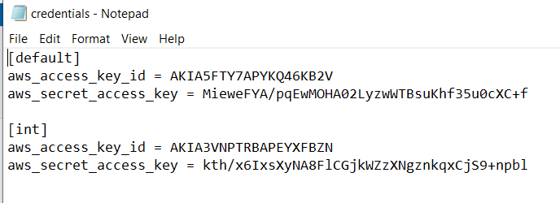

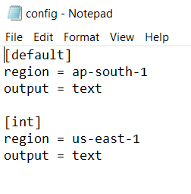

Cmd: export AWS_PROFILE=int

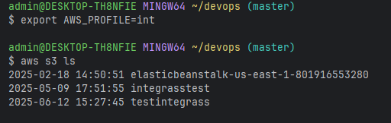

To check the login account

aws sts get-caller-identity --query "Account" --output text

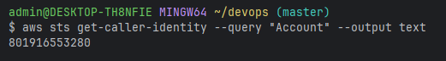

Create a EC2 instance using terraform code (without variable)

Using default vpc and default security group

Create the folder babaji-ec2

Under this folder create the providers.tf file

Providers.tf

terraform {  
 required_providers {  
 aws = {  
 source = "hashicorp/aws"  
 version = "6.0.0"  
 }  
 }  
}  
  
provider "aws" {  
 region = "us-east-1"  
}

create the ec2-babaji.tf file

resource "aws_instance" "babaji-ec2" {  
 ami = "ami-09e6f87a47903347c"  
 instance_type = "t2.micro"  
 security_groups = ["default"]  
 key_name = "babaji-RDS"  
 tags = {  
 Name = "babaji"  
 Env = "test"  
 }  
}

cd babaji-ec2

ls

terraform initi

terraform validate

terraform plan

terraform apply

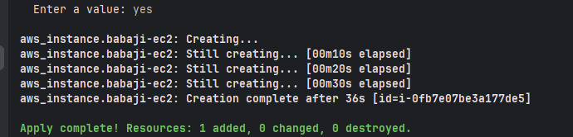

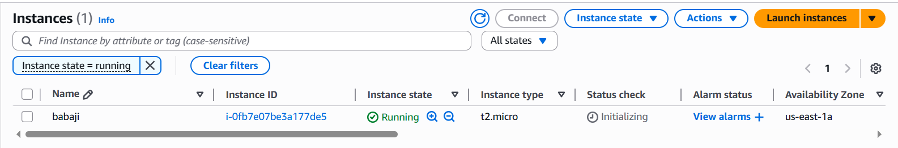

EC2 instances has been created.